**Accessing Oracle Apex online**

**Tutorial Topic 5 – Introduction to SQL**

<https://apex.oracle.com/pls/apex/f?p=4550:1:103565672582544>

**Then Create an Oracle Apex account using either your personal or Uel email.**

**Please note there are minor differences in different versions of SQL. Therefore there may be slight differences in some commands and syntaxes.**

**Recommended Tool:**

[**https://apex.oracle.com/pls/apex/f?p=4550:1:103565672582544**](https://apex.oracle.com/pls/apex/f?p=4550:1:103565672582544)

**Use Snipping tool to take the screen shots**

**Now click on Start Coding**

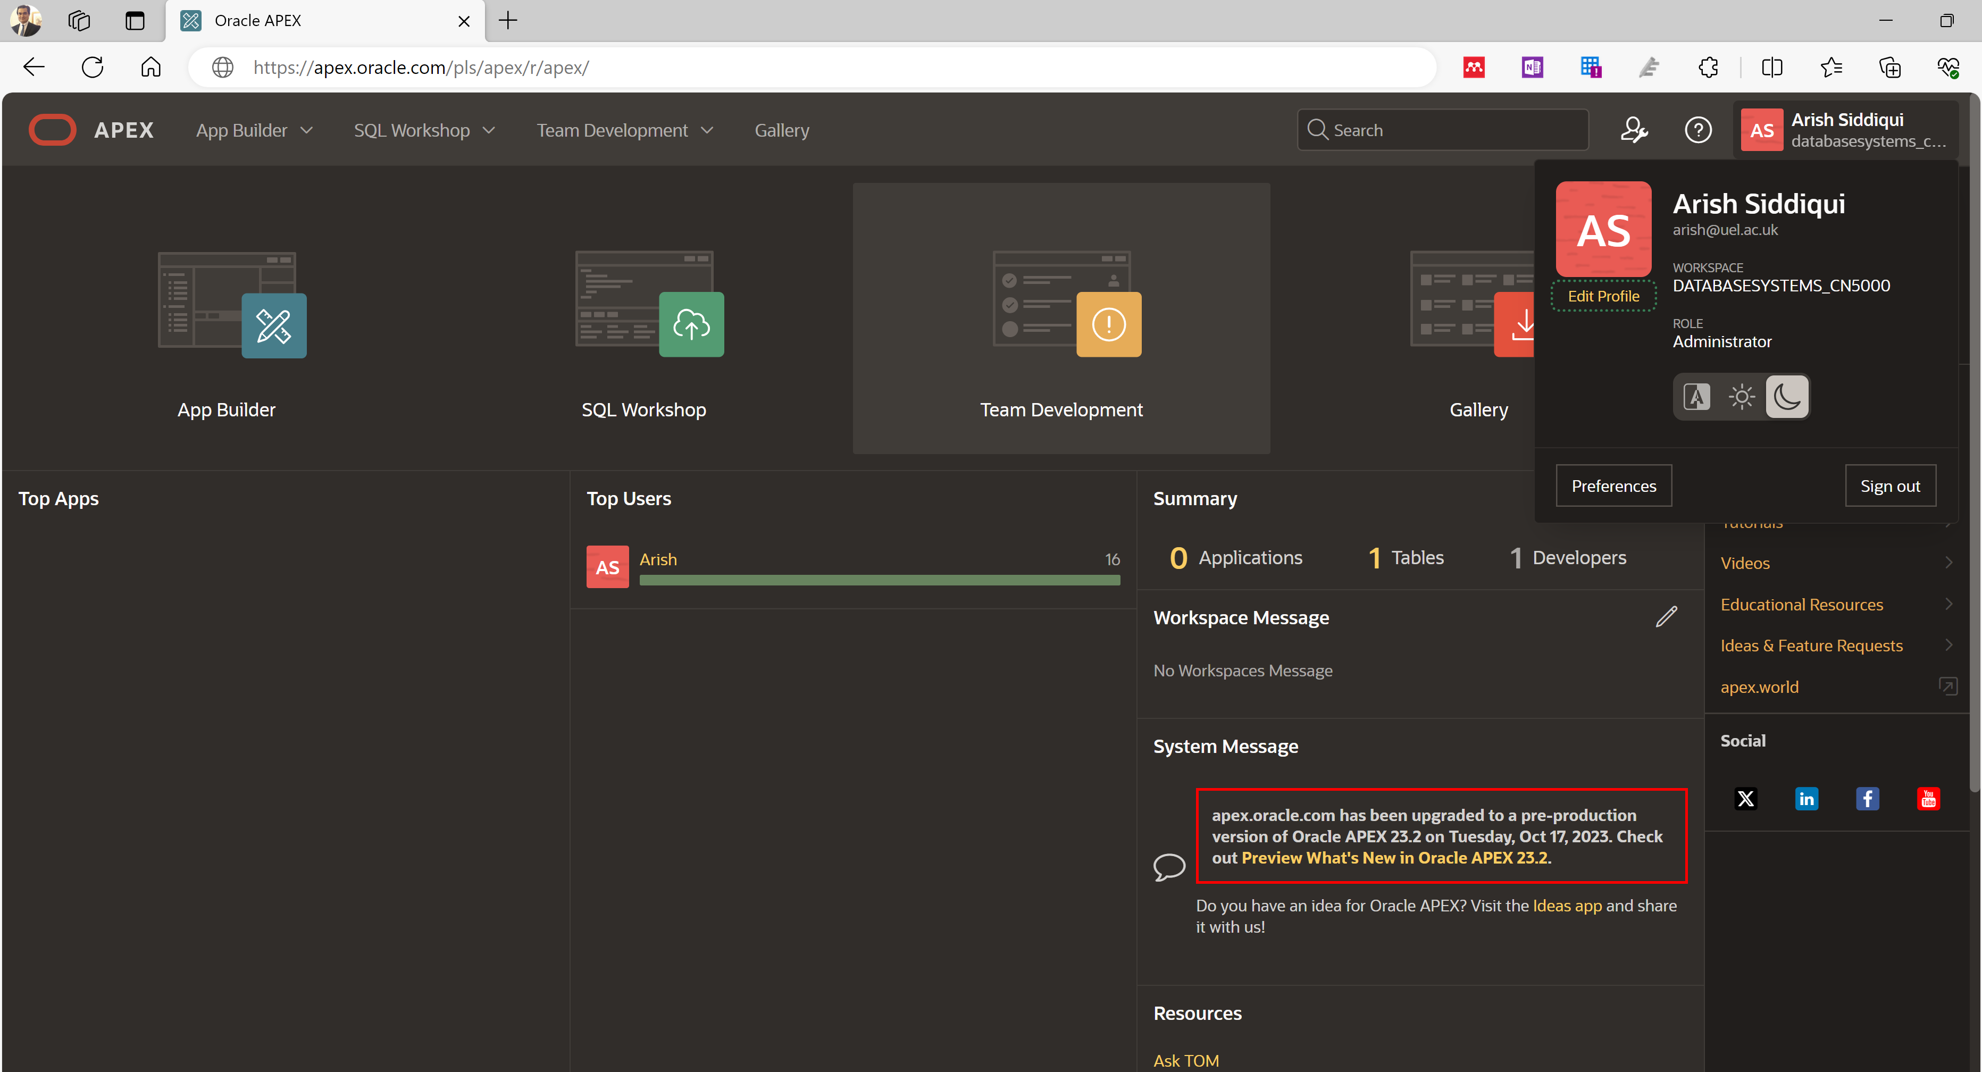 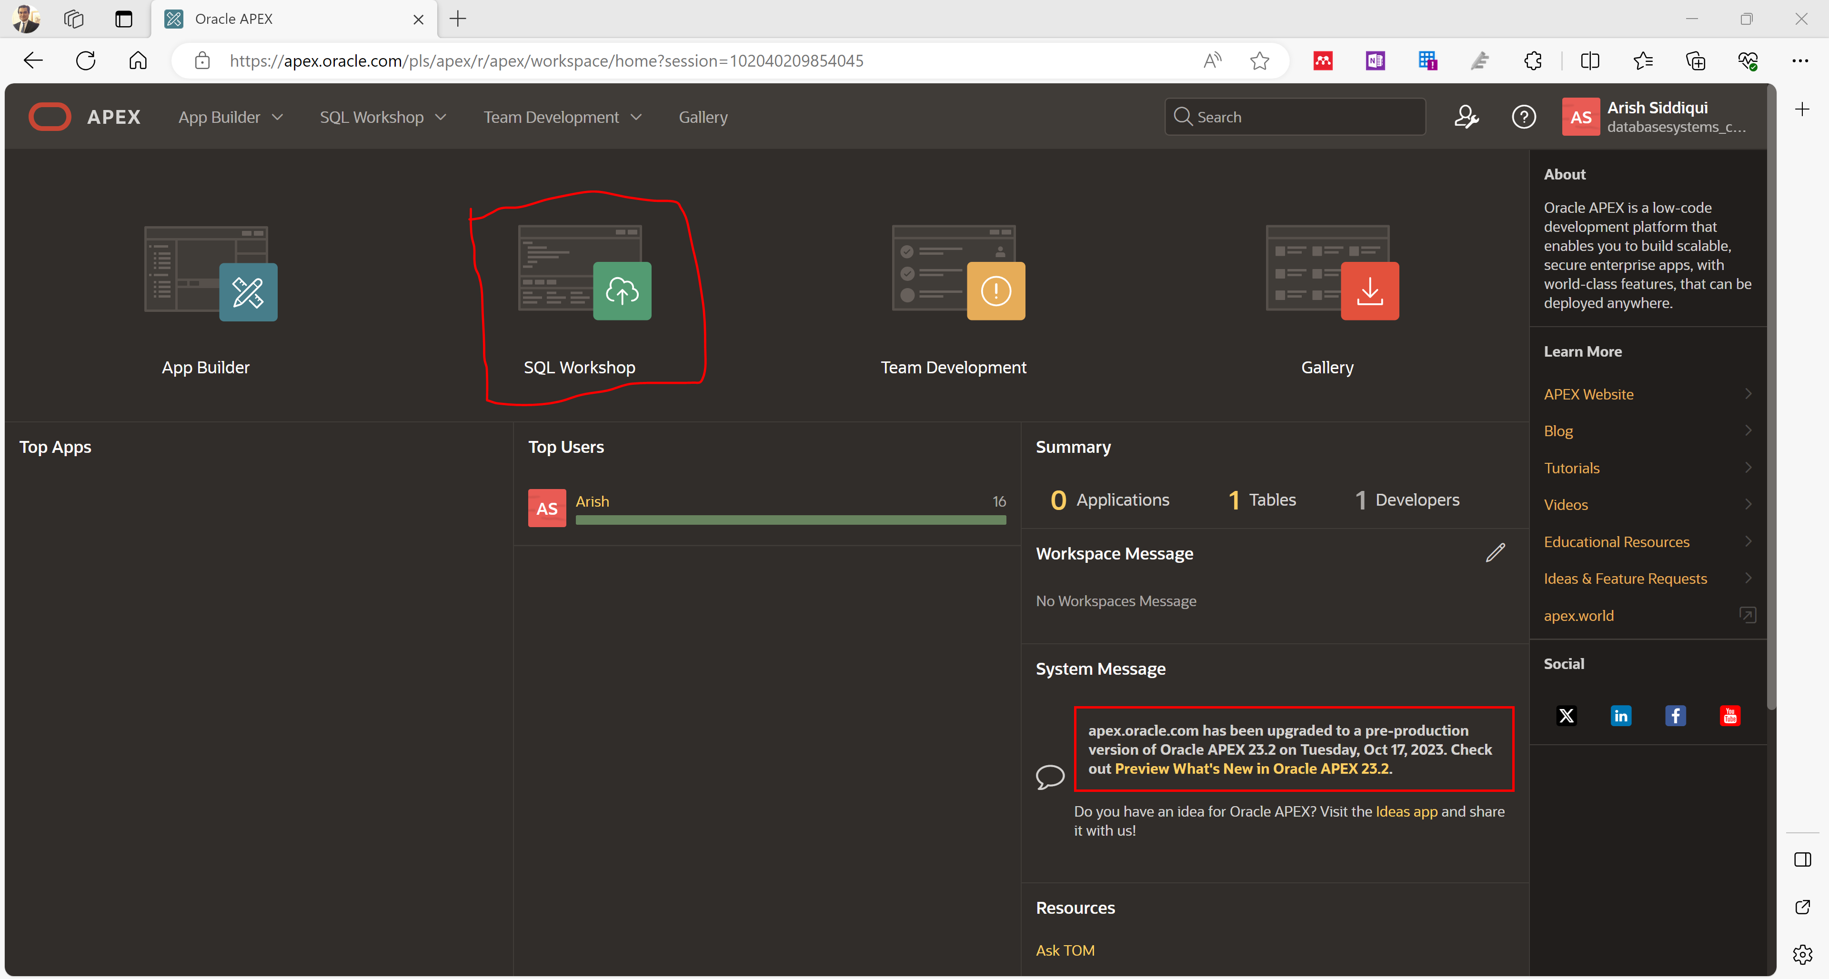

**And The following window will be launched**

**Write some statement and click on run button (on upper right)**

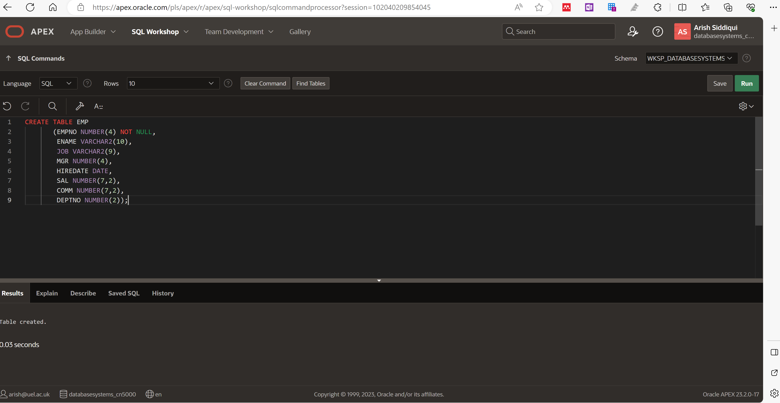

**The output shows the table has been created**

**Now follow the steps below to create a table, insert values and query values**

Explanation of some of the keywords/commands in the demo build sample script below:

* **Drop** – keyword command for deleting a table from the database Create – keyword for creating a table, index, objects etc.
* **Not null** – is a constraint used to ensure that a column must always have a value.
* **Comer** – used as separation of columns/field/headings
* **Semi-colon** – to end a statement Insert into – inserting values in table

**Creating Sample Database**

Please note, if this is the first time you are using Oracle at the University, none of the tables below would be in your Oracle Database. Therefore, when you type “Drop table Emp;” Oracle will display “table does not exist”. Do not worry. We will start with dropping tables just to be on safer side.

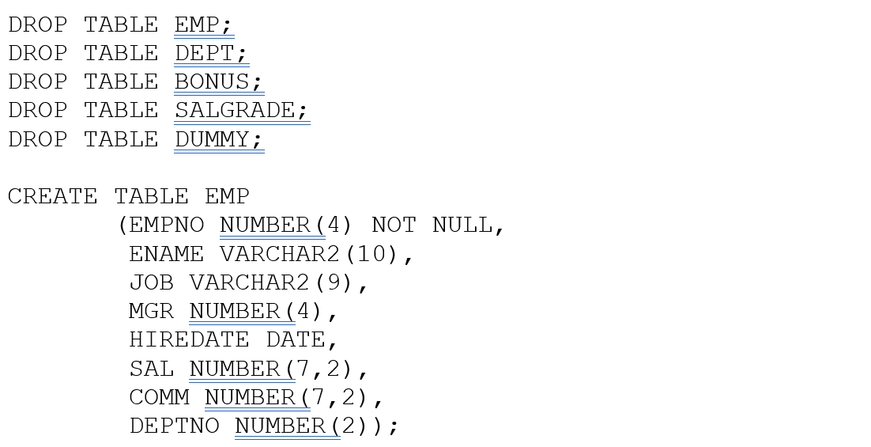

Once you have finished typing the above syntax to create the EMP table, you can display a description of the table, eg, the column headings and data type, by typing DESC EMP; then press the enter key.

To add rows in the tables, use the keyword/command “INSERT INTO”. Notice, when entering a number, you do not use quotation marks. Do so, only for text. Also, the values must be typed in the same order as the column headings.

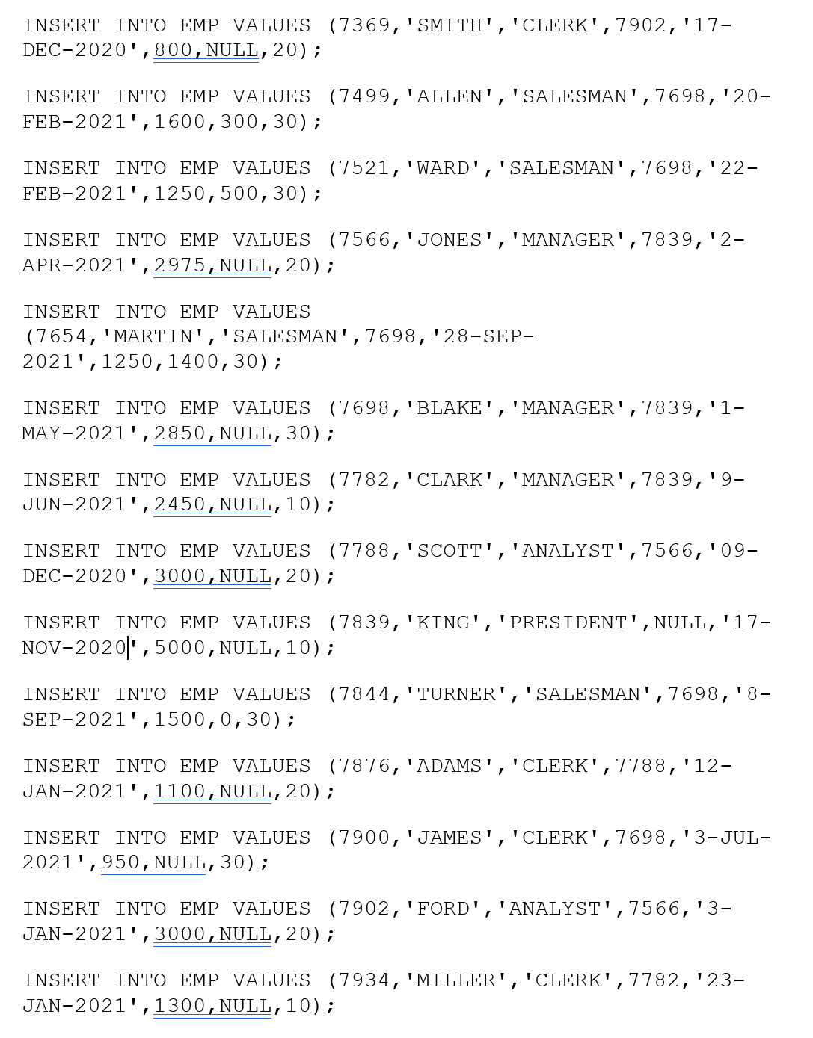

Once you have inserted the rows for the Emp table, you can view the table, by typing SELECT * FROM EMP;

You will notice that the columns are wrapping over – type SET NUM 7;

this will reduce the numeric columns and make the display more readable.

Now, either type the slash key / and press the ENTER key, to repeat the last statement, or type SELECT * FROM EMP; again to see the difference.

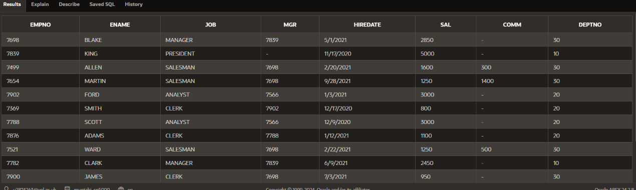

**TAKE A SCREEN SHOT AND SAVE**

To select specific attributes from the EMP table, eg, if you want to know the names of the employee and their salary. Type the following statement:

SELECT ENAME, SAL FROM EMP;

Continue creating the tables for the database and try the sample SQL statements.

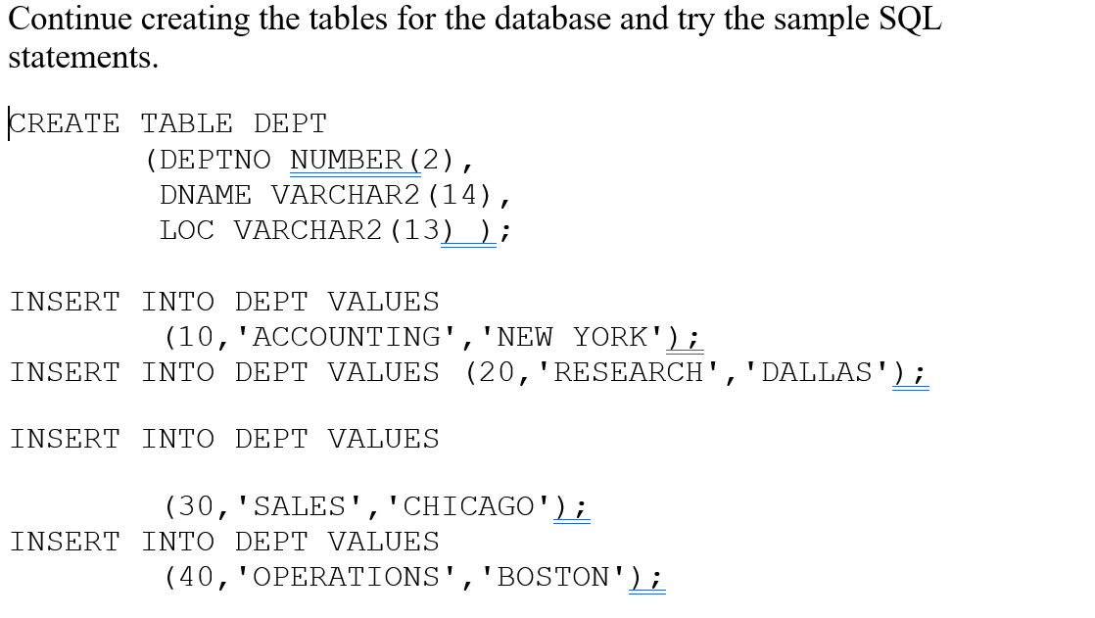

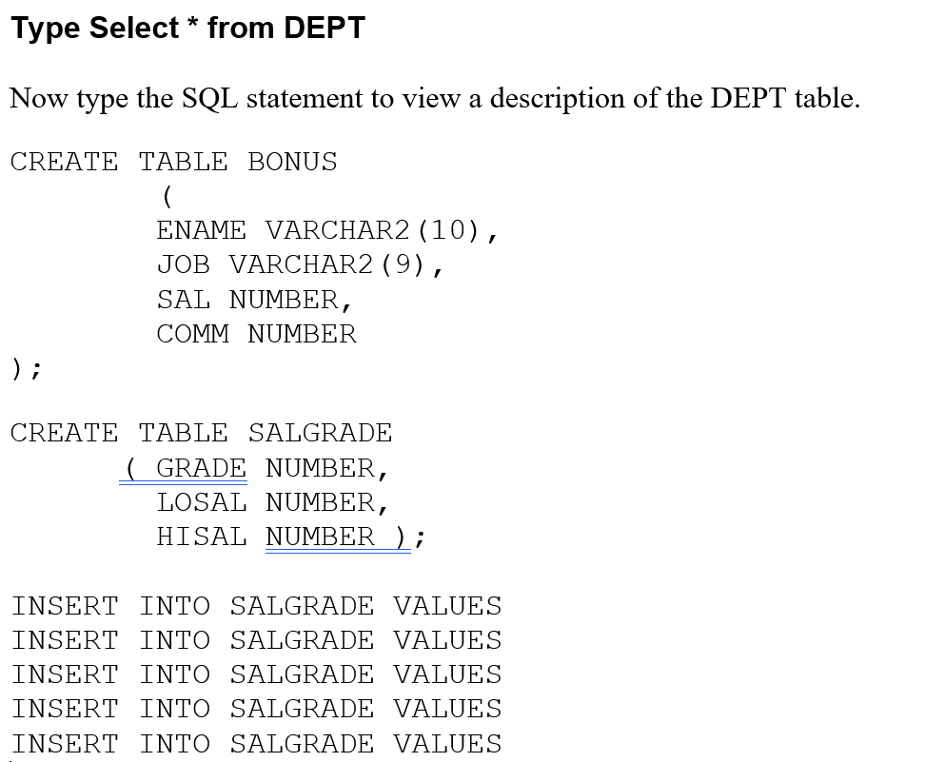

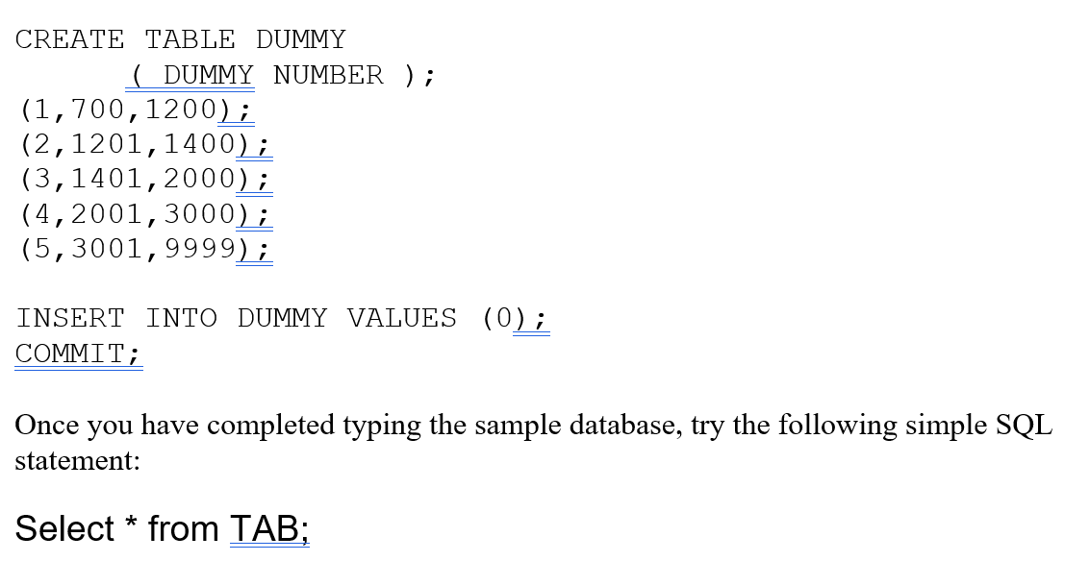

// This will display all available tables in (your) database.

Watch out there may be a an error somewhere 😊

**TAKE A SCREEN SHOT AND SAVE Happy SQL 😊**

**Please do not discuss MCQ in class, this to be covered as QUIZ.**

**SQL DDL Multiple Choice Questions**

1. **What does DDL stand for in SQL?**
   * A) Data Manipulation Language
   * B) Data Definition Language
   * C) Data Description Language
   * D) Data Display Language
2. **Which SQL statement is used to create a new table?**
   * A) CREATE TABLE
   * B) ADD TABLE
   * C) NEW TABLE
   * D) TABLE CREATE
3. **Which of the following SQL statements would you use to remove a table from a database?**
   * A) DELETE TABLE
   * B) DROP TABLE
   * C) REMOVE TABLE
   * D) CLEAR TABLE
4. **What SQL command is used to modify an existing table structure?**
   * A) CHANGE TABLE
   * B) UPDATE TABLE
   * C) ALTER TABLE
   * D) MODIFY TABLE
5. **Which of the following statements is used to define a primary key for a table?**
   * A) PRIMARY KEY (column_name)
   * B) KEY PRIMARY (column_name)
   * C) UNIQUE KEY (column_name)
   * D) INDEX (column_name)
6. **What is the purpose of the SQL statement CREATE INDEX?**
   * A) To remove duplicate records
   * B) To speed up the retrieval of rows
   * C) To enforce data integrity
   * D) To define a new table
7. **Which data type is used to store variable-length strings in SQL?**
   * A) CHAR
   * B) VARCHAR
   * C) TEXT
   * D) STRING
8. **Which SQL command is used to rename an existing table?**
   * A) RENAME TABLE
   * B) ALTER TABLE
   * C) CHANGE TABLE
   * D) MODIFY TABLE
9. **What does the CASCADE option do when dropping a table?**
   * A) It prevents the table from being dropped if there are dependencies.
   * B) It automatically drops any dependent objects.
   * C) It creates a backup of the table before dropping.
   * D) It locks the table from being accessed.
10. **Which of the following commands can be used to define a foreign key in a table?**
    * A) ADD FOREIGN KEY
    * B) CREATE FOREIGN KEY
    * C) FOREIGN KEY (column_name) REFERENCES other_table(column_name)
    * D) LINK FOREIGN KEY